:росток:Beet Seed

**BR#1**

iOS 18.1.1 Safari 18.2

The quantity indicator for products in the cart does not update when increasing the quantity of an added product.

Preconditions:

1. Main page is open <https://zoobonus.ua/>

STR:

1. Navigate to Health products.
2. Add a product in the cart.
3. Navigate to cart.
4. Change the quantity of added product.
5. Observe the result.

Expected result: The quantity indicator in the cart updates to reflect the increased quantity of the added product.

Actual result: The quantity indicator for products in the cart does not update when increasing the quantity of an added product.

Priority: High

Severity: Medium

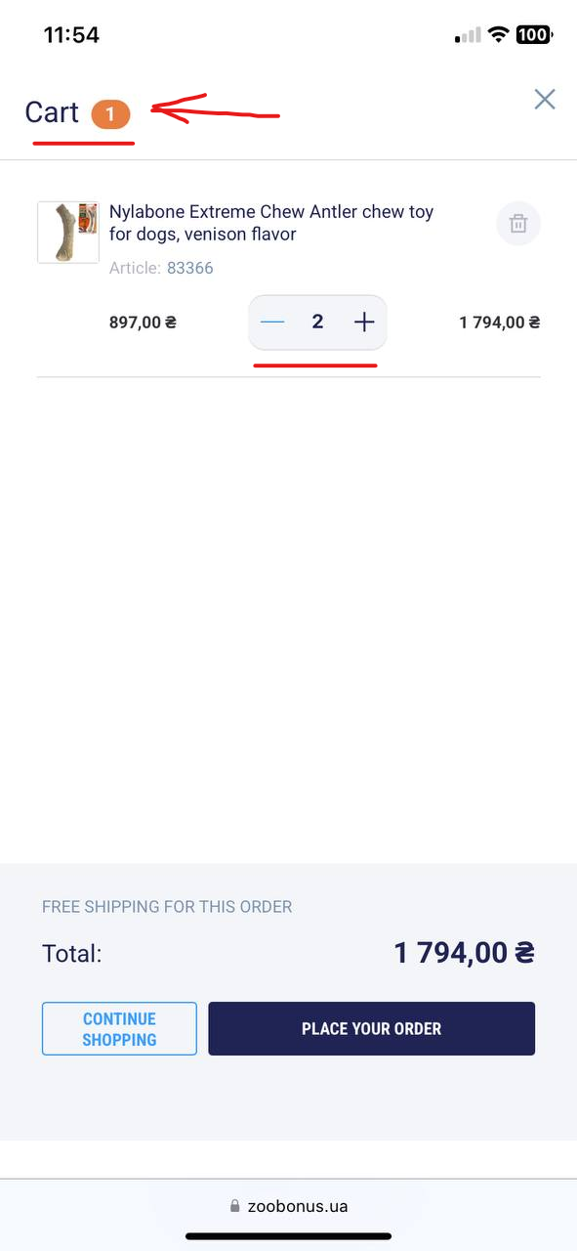

**BR#2**

iOS 18.1.1 Safari 18.2

The “Floor” field accepts letters in the checkout form.

Preconditions:

1. User is authorized on the site.
2. Product added to the cart.
3. Checkout page is open <https://zoobonus.ua/checkout>

STR:

1. In the “Floor” field, enter letters (e.g "A", "B", "C").
2. Observe the result.

Expected result: The "Floor" field only accepts numeric values (0-9) and rejects any letters.

Actual result: The "Floor" field accepts the letters without validation.

Priority: Low

Severity: Minor

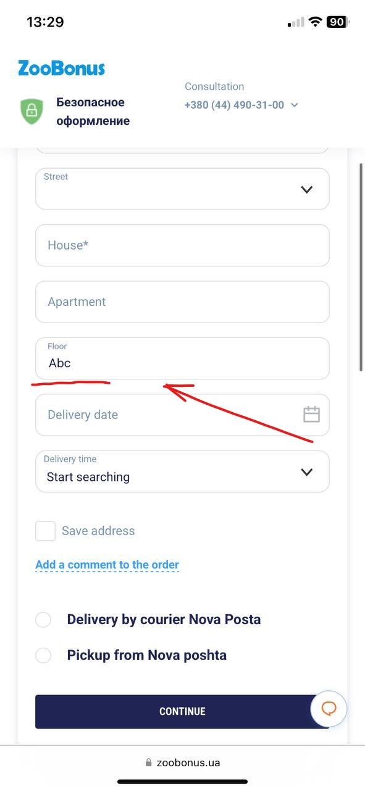

**BR#3**

iOS 18.1.1 Safari 18.2

Error message for the "Title" field on the review submission page is not informative when field is left empty

Preconditions:

1. User is authorized on the site.
2. The product page is open.

STR:

1. Tap on the “Write a review” button.
2. Leave the “Title” field empty.
3. Tap on the “Send” Button.
4. Observe the result.

Expected result: The error message should be “"Title" field is required.”

Actual result: Error message is not informative when the field is left empty.

Priority: Low

Severity: Minor

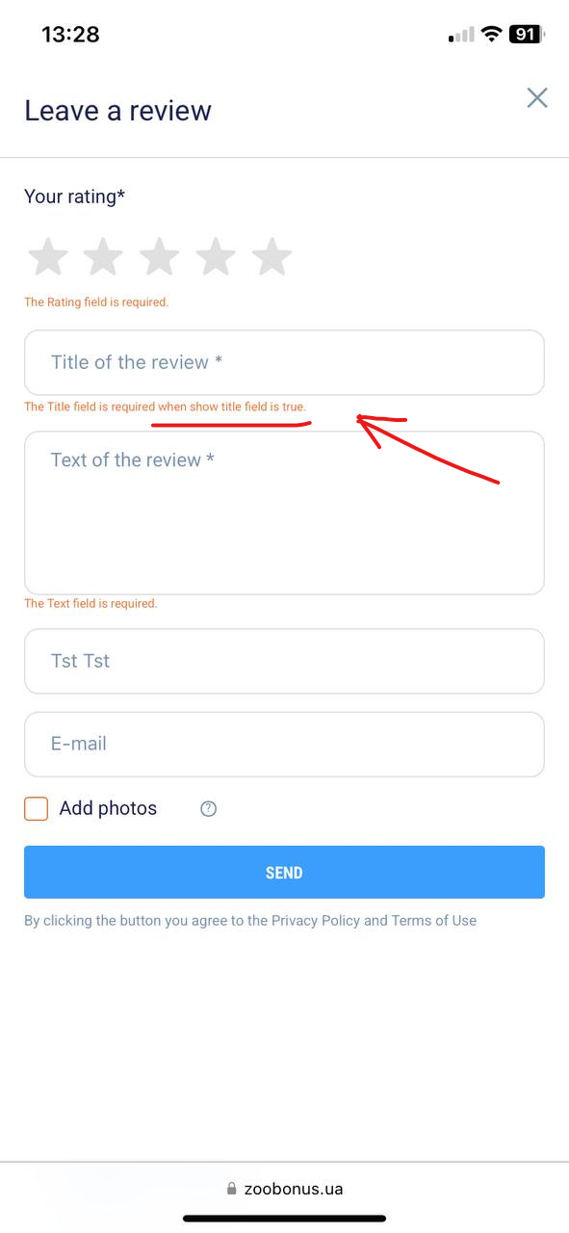

**BR#4**

iOS 18.1.1 Safari 18.2

Missing instructions for product "1st Choice Puppy Medium&Large Chicken dry super premium food for puppies of medium and large breeds 5 kg" on the product page.

Preconditions:

1. Product page is open <https://zoobonus.ua/en/catalog/1st-choice-puppy-medium-large-chicken-dry-super-premium-food-for-puppies-of-medium-and-large-breeds-5-kg-refil/p16367>

STR:

1. Navigate to the “About the product section”.
2. Tap on the “Instructions” button.
3. Observe the result.

Expected result: Instruction for the product is displayed in the “Instructions” page.

Actual result: Broken link is displayed in the “Instructions” page.

Priority: Low

Severity: Minor

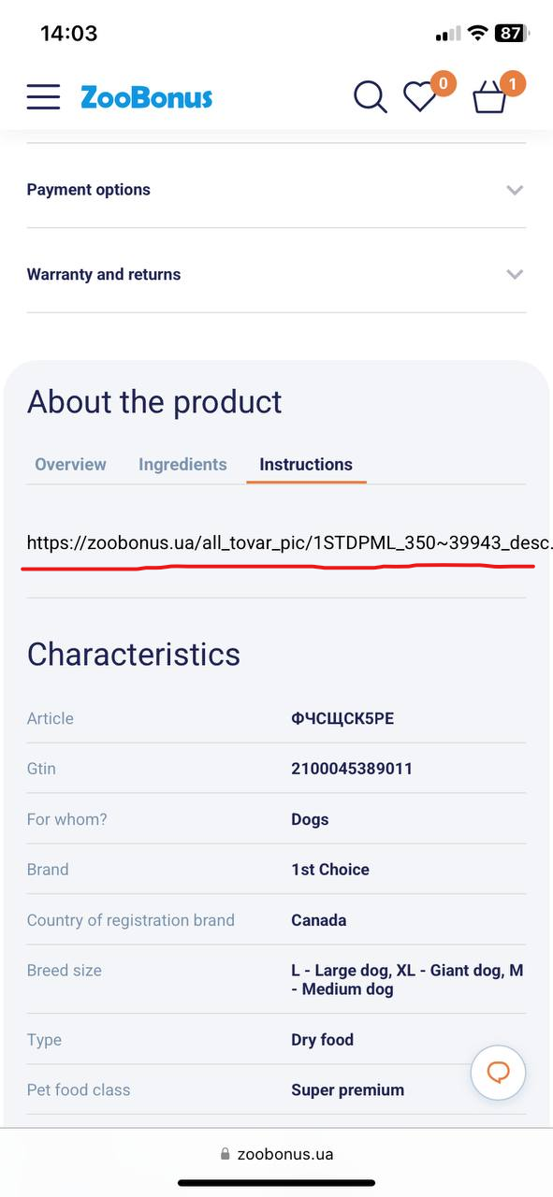

**BR#5**

iOS 18.1.1 Safari 18.2

Tooltip icon does not display the tip on the review submission page when taped on.

Preconditions:

1. User is authorized on the site.
2. The product page is open.

STR:

1. Tap on the “Write a review” button.
2. Tap on the tooltip icon.
3. Observe the result.

Expected result: The tooltip icon displays a tip when taped on.

Actual result: The tooltip icon displays a placeholder text when taped on.

Priority: Low

Severity: Minor

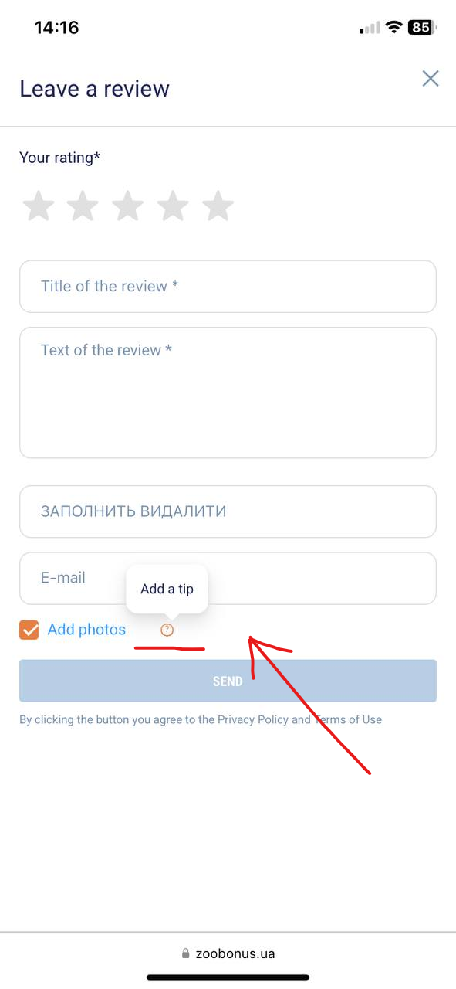

:травы: Beet Sprout

**BR#1**

OS: Android 15; Browser: Chrome 124.0.6367.219

Breadcrumbs in the header on the "Готель для кішок" page blend with the background image

STR:

1. Open the main page <https://zpolis.com.ua/>
2. Navigate to “Готелі для тварин Звірополіс” section.
3. Tap on the “Готель для кішок” button.
4. Observe the breadcrumbs in the header.

Expected result: The breadcrumbs are clearly visible against the background image

Actual result: The breadcrumbs blend with the background image, making them difficult to read.

Priority: Medium

Severity: Minor

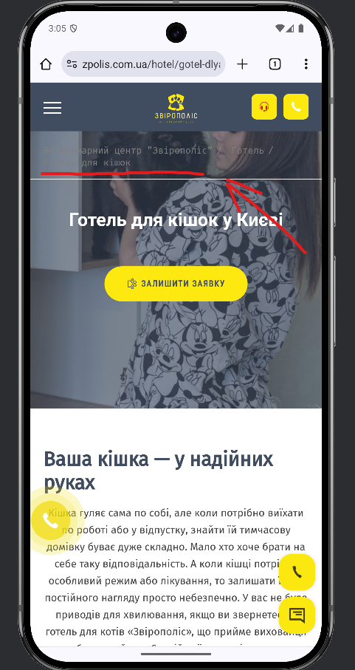

**BR#2**

OS: Android 15; Browser: Chrome 124.0.6367.219

Breadcrumbs navigation to the "Команда" page from the specialist page leads to an older version of the page

STR:

1. Main page is open: <https://zpolis.com.ua/>
2. Navigate to the “Наші фахівці” section and tap on “Дивитися всіх фахівців” button.
3. Tap on the picture of the specialist.
4. Use breadcrumbs to navigate back to the “Команда” page.
5. Observe the result.

Expected result: Clicking the breadcrumbs to navigate to the "Команда" page directs the user to the current version of the page.

Actual result: The breadcrumbs navigation leads to an outdated version of the "Команда" page.

Priority: High

Severity: Medium

Video link: <https://youtu.be/vDTxZSv7YvE>

**BR#3**

OS: Android 15; Browser: Chrome 124.0.6367.219

"Замовити" button is visually active, but not clickable in the “Замовити дзвінок” window if the phone number field is left empty.

STR:

1. Main page is open: <https://zpolis.com.ua/>
2. Tap on the “phone” icon on the right bottom corner of the page.
3. Leave the phone number field empty.
4. Attempt to tap on “Замовити” button.

Expected result: The "Замовити" button either displays an informative error message, prompting users to enter a phone number or remains inactive with clear feedback.

Actual result: The "Замовити" button is not clickable, but no feedback is provided to indicate the issue.

Priority: High

Severity: Medium

